Daniel Heifetz
301-854-2960
dbheifetz@gmail.com

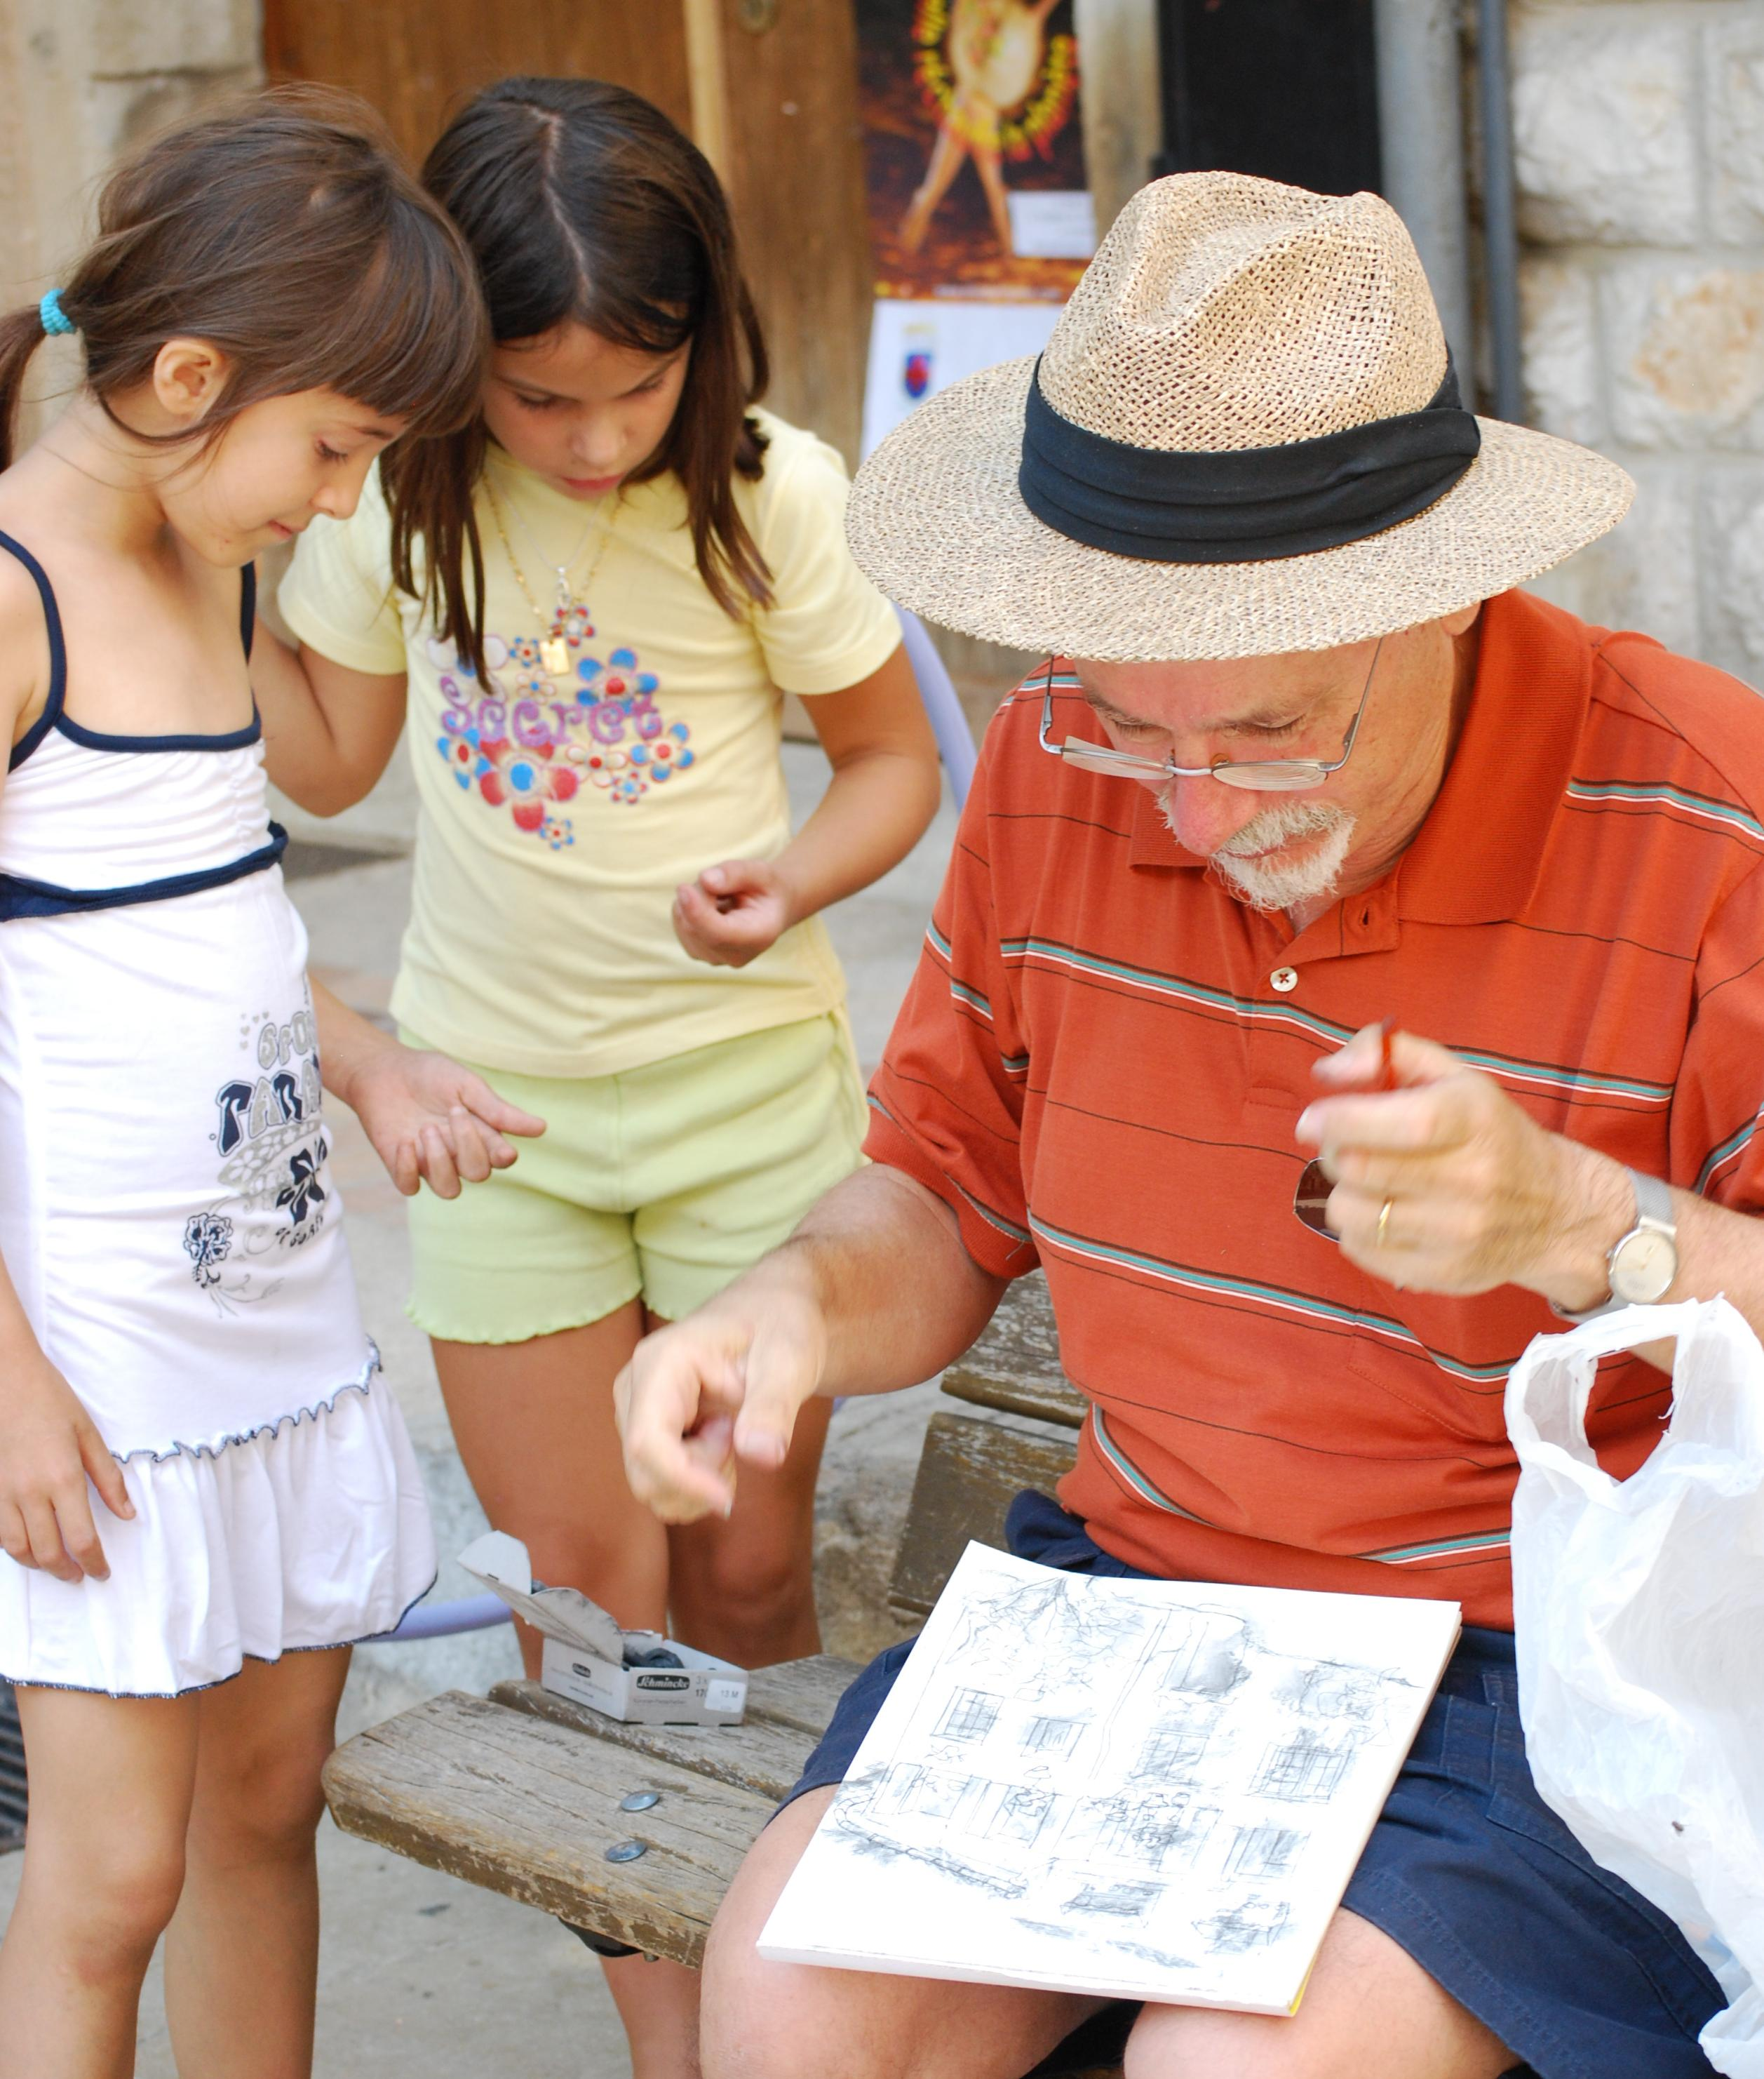

Ph.D. Mathematics, Columbia University, N.Y., 1981

Long ago studied art when I could at San Francisco Art Institute, California College of the Arts, Oakland, Univ. of Calif., Berkeley, Art Students League, NYC, and more recently at Howard Community College, MD

Winner of the President’s Award,
Fall 2008 Students Show, HCC.

On line at www.flickr.com
Click on “search”, then “people”, and search on “danielborisheifetz”

One the right: “Between poses” (top), “Before People’s Park, Berkeley, 1968” (middle), “Reading in the Tuileries” (bottom).



